General Information
52nd RL24 National Championships
hosted by Lake Wellington Yacht Club Victoria
6th – 10th January 2025

Proudly supported by
The Middle of Everywhere
Follow link to see what to do in our area
History:
Established in 1960, the club has grown from a shed on the foreshore into the complex it is today.
Lake Wellington Yacht Club boasts a very proud history with RL24s. Over the years more than 22 RL24’s have been members at LWYC with 17 of those starting their life on Lake Wellington. It is 25 years since the last RL Nationals at LWYC and the club is very keen to make the 52nd Nationals a great event.

Claim to Fame:
Since 1969, LWYC has been the home of the iconic Marlay Point Overnight Race, the premier trailersailer event in Australia, maxing out at 688 entries in the peak of the 1980’s.

Location:
The club is located on the most western shore of Lake Wellington on the Gippsland Lakes, 20 Km’s from Sale, the region has a lot to offer and is promoted as The Middle of Everywhere who have provided support for Our Nationals so please check out the website, we encourage you to stay longer to explore our area from the mountains to the sea.
Note:
Our clubhouse is the only facility at this location and is entirely volunteer run.
Nearest town is Sale with all facilities expected of a large country town of 16,000 people, with many restaurants, pubs, supermarkets and accommodation options.
Facilities:
The clubhouse is a two level A frame construction with a large balcony looking over the race course (great for spectators) all accessible by disability access ramp, facilities include Bar, kitchen, dining room, toilets and showers. Adjacent to the clubhouse is 10 acres of land for easy boat storage and camping. There is a large sealed carpark area adjacent a good concrete double ramp with floating jetty for easy access.

Accommodation:
If camping at the club is not your thing, Sale and surrounding area has a large range of accommodation options ranging from budget to luxury, a quick search on Google, Air BnB or Booking .com will revel many options available. Book early to secure your suitable accommodation style.

Camping:
Please note: camping is offered for your convenience and is not a full facility camping ground.
To book camping please visit the website for Campsite Booking form, limited powered sites will be issued on a first to book basis. https://www.lakewellingtonyachtclub.org/events/

Need to Hire a caravan?
There are a number of options.
- Camplify https://www.camplify.com.au/s/sale-VIC-3853?seed=60535&page=1
- Caravan Hire Co. https://caravanhireco.com.au
- Sale Caravan Hire tends to be older style vans, so be sure you are aware of what you are booking. Ph. 0428564121
- Some Club members might have vans available for hire under private arrangements.

Water:
Our facilities rely on rain water, please ensure everyone uses water sparingly.

Further information can be found online:
https://www.lakewellingtonyachtclub.org
https://www.facebook.com/LakeWellingtonYC
Call Darryn Dyer 0409338916
(please leave message if unanswered)

Clubhouse balcony looking at boat ramp
Clubhouse, car and trailer parking & boat ramps
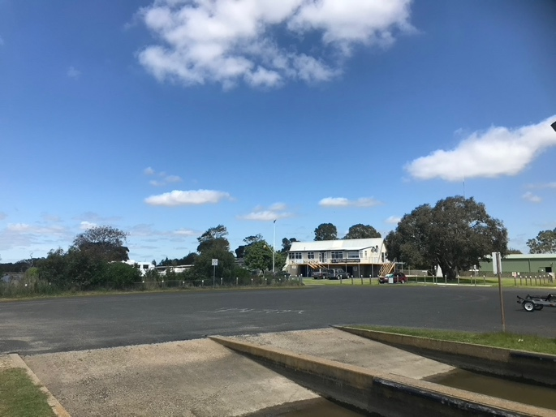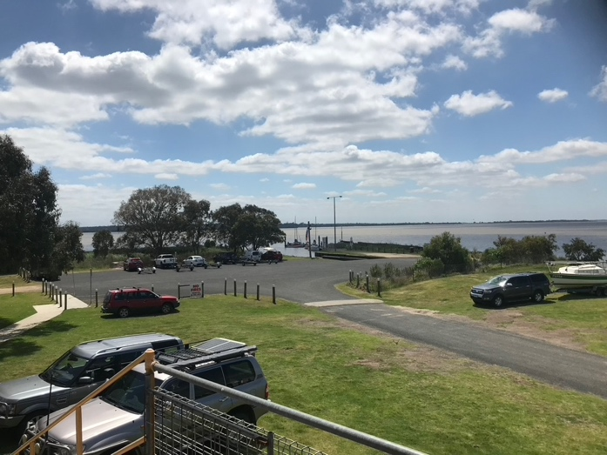
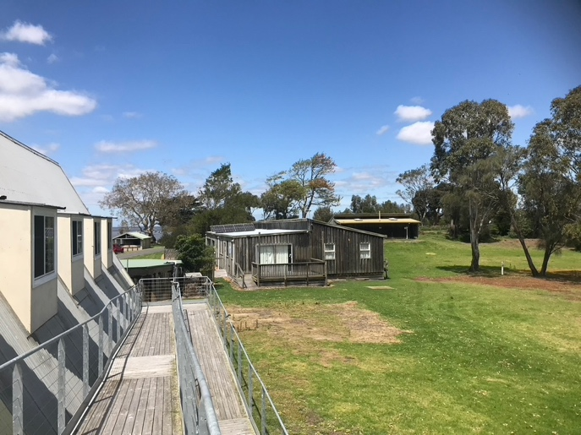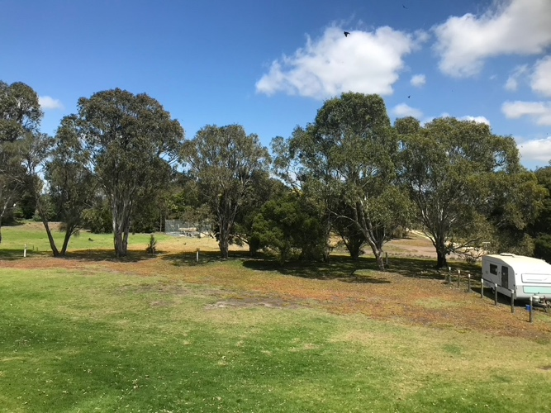
Camping area
Access ramp and camping area
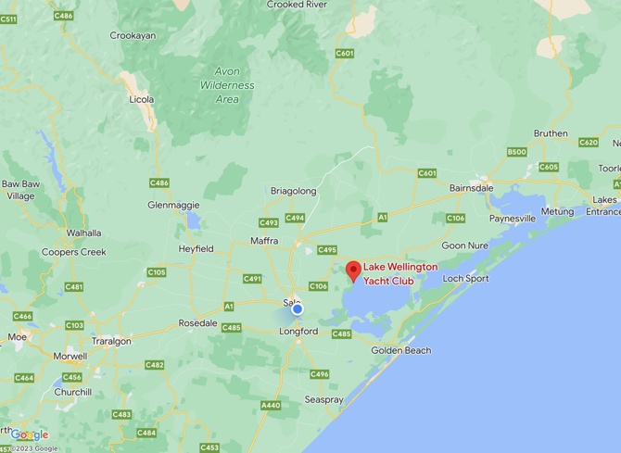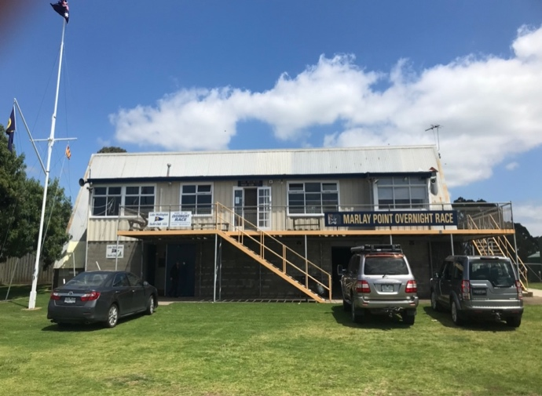
LWYC Clubhouse

